ASSIGNMENT 2 REPORT
Dashboard Screenshot
Name:Ong Ying Tong
MonashID: 34477306
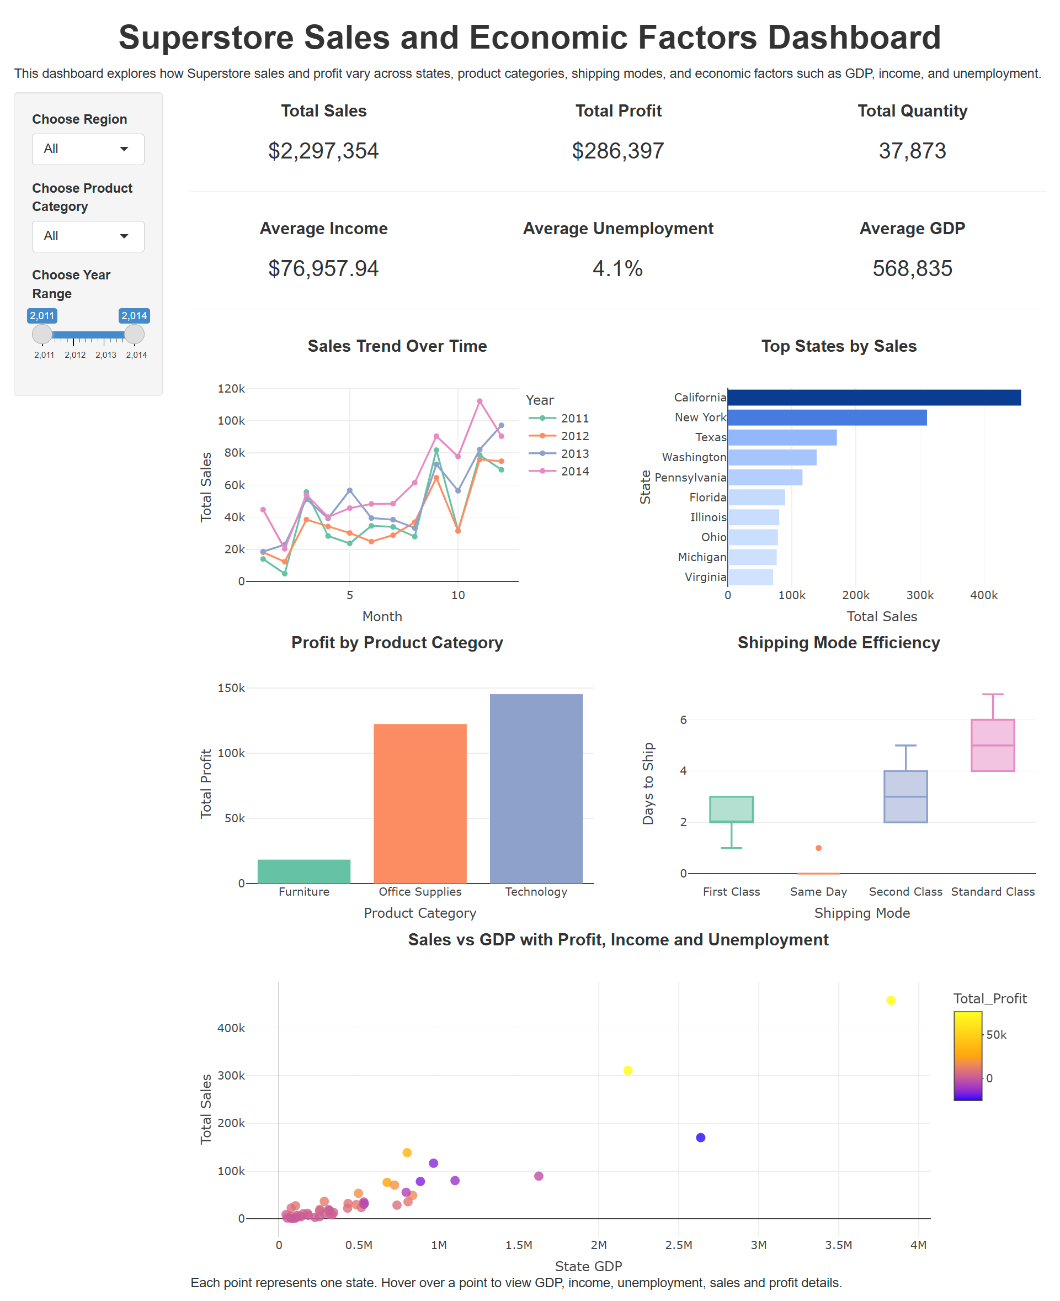

Problem Design
Problem statement
Superstore faces a state-level profitability problem where high sales do not always translate into strong profit. The key issue is how Superstore can identify which U.S. states and product categories are truly profitable, instead of relying only on sales volume. This dashboard also examines whether external economic factors such as GDP, median household income, and unemployment rate help explain differences in state-level business performance.
The Solution
To address this problem, the dashboard combines Superstore’s internal business data with three external economic indicators: GDP, median household income, and unemployment rate. Superstore data shows sales, profit, discount, product category, customer segment, shipping mode, and state, while the external datasets explain the wider state-level market conditions. GDP represents market size and economic activity (Bureau of Economic Analysis, 2024), median household income represents customer purchasing power (HDPulse, 2026), and unemployment rate represents labour market stability and demand risk (Bureau of Labor Statistics, 2024). This combined dataset allows the dashboard to compare business performance with economic context and identify strong markets, margin-risk markets, and potential opportunity markets.
The Result
The combined GDP, income, unemployment, sales and profit visualisation shows that external economic strength can help explain market potential, but it does not fully determine profitability. California appears as the strongest market in the dashboard because it has the highest Superstore sales at about $457,731, strong profit at about $76,381, and a very large GDP of about $3,827,007. This suggests that states with larger economies may provide stronger sales opportunities for Superstore. However, the chart also shows that economic strength alone is not enough to guarantee profit. Some states such as Ohio with higher GDP still have weaker or negative profit, meaning Superstore must also manage internal business factors such as discounting, shipping costs and product mix. For example, smaller states such as Vermont have much lower sales at about $8,929, but still record positive profit at about $2,245, showing that lower sales markets can still be financially efficient. Overall, the result shows that Superstore should not judge markets by sales or GDP alone. The dashboard compares Superstore’s sales and profit performance with external economic indicators such as GDP, income, and unemployment. This helps the business identify where expansion is justified by both strong market potential and strong returns, where profit control is needed despite high sales, and which smaller markets should still be maintained because they continue to generate positive profit.

Dataset Selection
The Superstore dataset is the main dataset for this dashboard. It includes sales, profit, quantity, product category, customer segment, shipping mode, region, and state-level data. This allows for an analysis of business performance based on such variables. However, analysis using only the Superstore dataset mainly identifies which areas perform well or poorly in terms of sales and profit. Hence, three external economic datasets are included to examine whether state-level economic factors help explain differences in Superstore business performance.
The first external dataset is the GDP dataset from the Bureau of Economic Analysis (BEA). This dataset provides state-level Gross Domestic Product values, which represent the total economic output and overall economic strength of each U.S. state (BEA, n.d.). This dataset was selected because GDP is a useful indicator of market size, business activity, and economic capacity. From a business perspective, states with higher GDP may have larger commercial markets, stronger demand conditions, and more active economic environments. It complements the Superstore dataset by allowing the dashboard to examine whether states with stronger economies are more likely to generate higher Superstore sales. This helps move the analysis beyond simple sales ranking by connecting sales performance to the broader economic strength of each state.
The second external dataset is the income dataset from the HDPulse Data Portal. This dataset provides median household income values for each U.S. state, which reflect the general purchasing power of households across different states (HDPulse Data Portal, n.d.). In business analysis, higher household income may indicate stronger consumer purchasing capacity, while lower income may limit demand or increase price sensitivity. It complements the Superstore dataset by helping the dashboard investigate whether higher-income states tend to show stronger sales performance. This is useful because Superstore sales are influenced not only by product availability or category demand, but also by the financial ability of customers in each state to purchase goods.
The third external source is the unemployment dataset from the Bureau of Labor Statistics. This dataset contains unemployment rates at the state level, expressed as a percentage of the labour force. It illustrates labour market conditions in the U.S. (Bureau of Labor Statistics, n.d.). This source was chosen as unemployment rates can be used to measure economic pressure. When joblessness is higher, households may face lower income security and become more cautious with spending. It complements the Superstore dataset by helping the dashboard examine whether weaker labour market conditions are associated with lower Superstore sales across states.
In conclusion, the three external datasets provide a more complete business context for analysing Superstore performance. The GDP dataset indicates the economic size of each state, while the income dataset reflects consumer purchasing power. Similarly, unemployment explains labour market pressure. Therefore, these datasets allow the dashboard to better investigate why sales performance may be stronger or weaker across different U.S. states, rather than only describing the sales results.

Visualization 1: Sales Trend Over Time
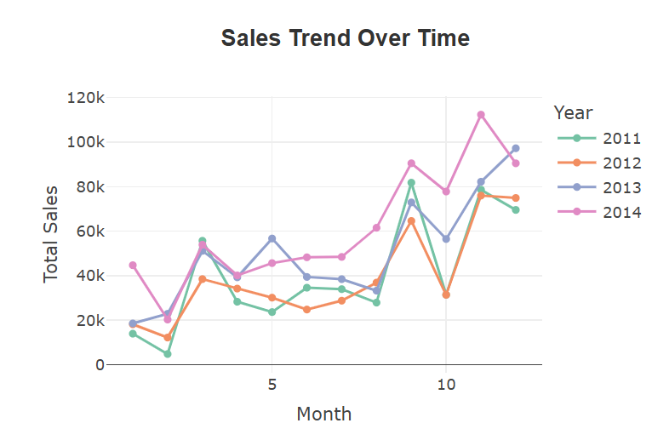

The above line chart illustrates the monthly sales of the Superstore dataset between 2011 and 2014. The steps to build this visualisation include converting the order date column into a date format and extracting the month information from it. Next, the data was filtered for the year and month and the summarize function was applied on the data to compute the sum of sales for every month. Line graphs used to understand how sales trend with time.
Overall, sales tend to rise toward the end of the year, especially around Month 12. For example, December sales were approximately $69,545 in 2011, $74,917 in 2012, $97,247 in 2013, and $90,475 in 2014. This suggests that sales are usually stronger near the year-end period, possibly due to seasonal demand, business purchases, or holiday-related spending. The chart also shows that 2014 generally had stronger monthly sales than earlier years, especially in the second half of the year.
This visualization adds a time-based business perspective to the analysis. Even if some states have stronger economic conditions, sales also change throughout the year, so Superstore should not only consider location-based performance but also seasonal timing. From a business perspective, the stronger year-end sales pattern suggests that Superstore could prepare earlier for busy periods by increasing stock availability, planning promotions, and allocating staff more effectively. This would help the business take advantage of peak demand and reduce the risk of missed sales opportunities.

Visualization 2: Top States by Sales
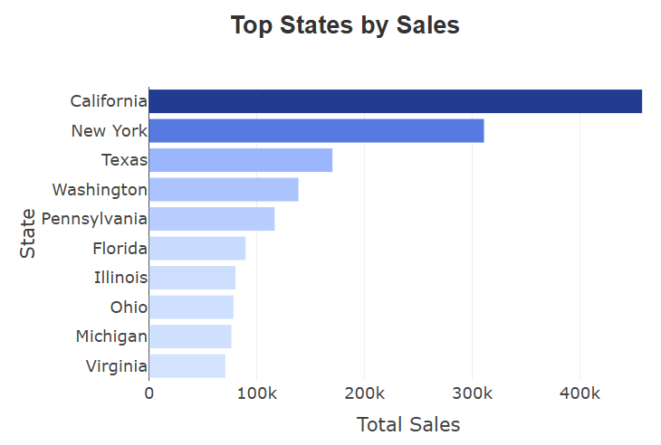

The above is the horizontal bar graph that highlights the top ten states in the USA with the highest total Superstore sales. To generate this chart, the data in the cleaned Superstore dataset was filtered to include only the US states. This was done using the summarise () function based on state. The states were arranged by total sales, and the top 10 were selected for comparison. A horizontal bar chart was used because it makes state names easier to read and clearly shows the sales ranking.

The colour gradient helps highlight the difference in sales performance. Darker blue bars represent higher total sales, while lighter blue bars represent lower total sales among the top 10 states. California has the highest sales at approximately $457,731, followed by New York with about $310,914. Texas is also one of the strongest states, while Virginia, even though it is still in the top 10, has much lower sales at around $70,641. This shows that sales are highly concentrated in a few major states.

This visualizes the performance of sales at Superstore's dataset. In terms of business, it can be seen that states like California and New York could be major markets for Superstore, as they produce far higher sales compared to other states. This chart helps identify where Superstore is performing well and which states may be important to investigate further when comparing sales with external factors such as GDP, income, and unemployment.

Visualization 3: Profit by Product Category

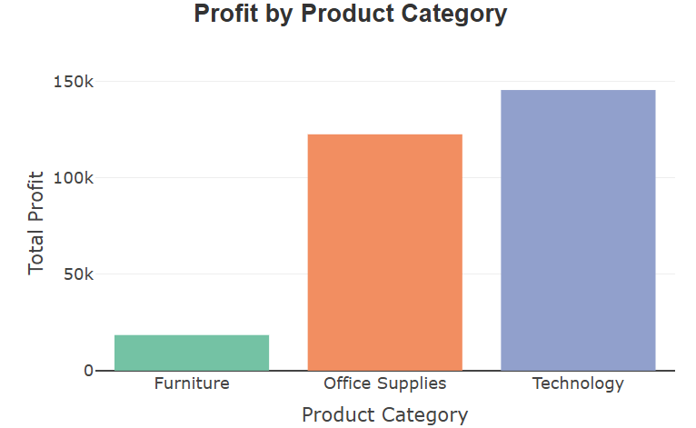

This bar chart compares total profit across the three Superstore product categories: Furniture, Office Supplies, and Technology. To create this visualization, the cleaned Superstore data was grouped by Category, and summarise() was used to calculate the total profit for each category. A bar chart was chosen because it clearly shows which product category contributes the most profit and allows easy comparison between categories.
The chart shows that Technology generates the highest profit at approximately $145,455, followed by Office Supplies with about $122,491. In contrast, Furniture produces much lower profit at around $18,451. This indicates that although all categories contribute to the business, they do not contribute equally. Technology and Office Supplies appear to be the main profit drivers, while Furniture has weaker profitability.
From a business perspective, this visualization is important because high sales do not always mean high profit. Superstore should pay attention to which categories create stronger margins and which categories may need improvement. The lower profit from Furniture may be linked to higher discounts, shipping costs, or lower margins. This insight can help the business review pricing, promotion strategies, and cost control for Furniture, while continuing to support strong-performing categories such as Technology and Office Supplies.

Visualization 4: Sales Distribution by Product Category

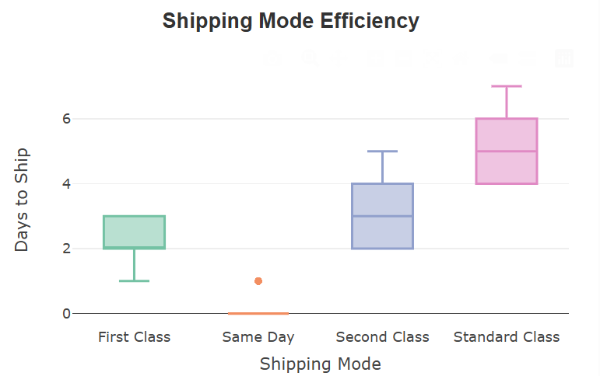
This boxplot compares the distribution of individual order sales across the three Superstore product categories: Furniture, Office Supplies, and Technology. To create this visualization, the cleaned Superstore dataset was grouped visually by Category, with Sales used as the numeric variable. The selection of a boxplot was done because it illustrates both the typical sales and also their spread and even any high-valued sales.
From the boxplot, the number of high-cost products is low for all categories, yet there is an outlier in every single category. Technology has the highest price of sales of up to almost $22,638, while Furniture has up to $4,416 and Office supplies up to $9,893. Furthermore, the median price of Technology's sale is $166, while the median sales for Furniture are $182 and $27 for Office Supplies, respectively. Thus, it can be suggested that there is a higher frequency of sales made for office supplies, and the technology sale consists of larger amounts.
From a business perspective, this visualization shows that sales performance is not only about total revenue, but also about the type and size of orders within each category. It seems that the high-cost purchases are typical for the technology products category and may be the reason for it being the most profitable one.

Visualization 5: Sales vs GDP with Profit, Income and Unemployment

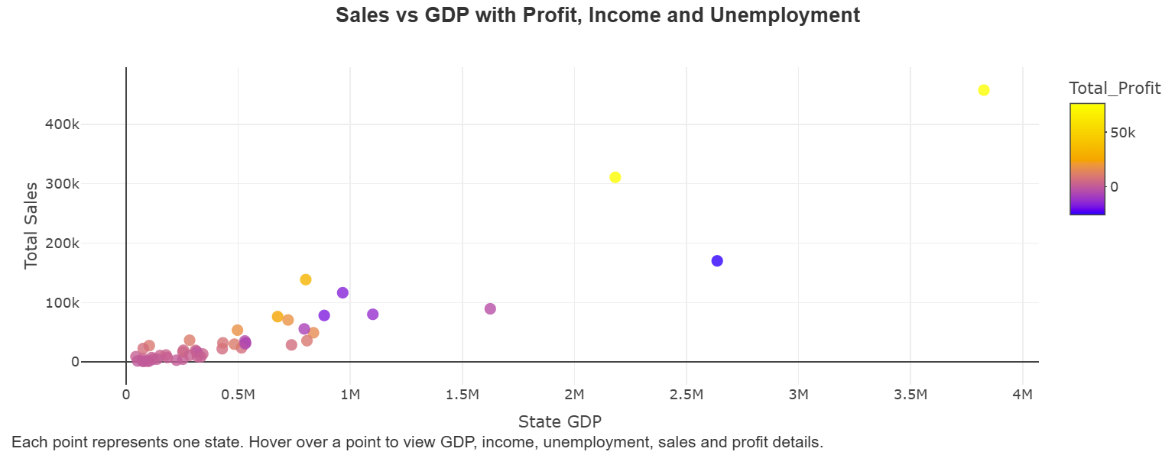

The scatter chart merges the Superstore sales data on a state level with the three external economic datasets. For the creation of this scatter plot, Superstore sales and profit have been grouped by State, and then sum of sales and sum of profits for each State have been calculated using summarise().
The result was then joined with the external GDP, income, and unemployment datasets using left_join().
The chart shows a general positive relationship between GDP and sales. States with larger economies tend to have higher Superstore sales. For instance, California is highest leading in terms of sales with sales worth approximately $457,731, having a GDP of about $3,827,007, income of about $96,334, and an unemployment rate of 5.4%. However, the chart also shows that economic size does not guarantee high profitability. Texas has relatively high sales of about $170,187 and GDP of about $2,637,238, but its total profit is negative at around -$25,729. This suggests that sales volume alone is not enough to judge business performance.
From a business perspective, this visualization is important because it links Superstore performance with broader state economic conditions. High-GDP states may provide larger market opportunities, but the business still needs to manage profitability through pricing, discounts, shipping costs, and product mix. These figures help give additional information on the purchasing power and employment status. In general, this graph indicates that Superstore should not only consider the economically stable regions, but also investigate why some high-sales states are less profitable.

Data Story
The dashboard tells a clear business story: Superstore should focus on profitable growth, not simply higher sales. The visualisations show that sales, profit, discounting, product category, customer segment and state economic conditions are connected. A state or category with high sales is not automatically a strong business area if the profit is weak. For Superstore, the key business question is where sales are producing strong profit, where revenue is being reduced by discounts or shipping costs, and which states have stronger external economic conditions to support future growth.
The state and region visualisations show that Superstore’s performance is uneven across locations. States with both high sales and high profit are the strongest markets because they show customer demand and financial return at the same time. These markets should be prioritised for stock availability, customer retention and targeted promotion. However, states with high sales but low profit require a different decision. Superstore should not automatically increase advertising or discounts in these states because more sales may make the profit problem worse. Instead, the business should review discount levels, shipping costs and product mix to understand why sales are not converting into profit.
The GDP dataset strengthens the state-level analysis because it shows the economic size and market strength of each state. GDP is relevant because a stronger state economy usually indicates more business activity and retail potential. The Bureau of Economic Analysis reported that real GDP increased in 49 states and the District of Columbia in 2023, and retail trade increased in all 50 states and the District of Columbia (Bureau of Economic Analysis, 2024). This supports the use of GDP as an external dataset because Superstore operates in retail. If the dashboard shows a state with high GDP but low Superstore sales, the business should treat it as a missed market opportunity. The issue is unlikely to be weak economic potential; it may be weak customer reach, poor product targeting or limited regional strategy.
The income dataset adds another layer of business logic because income affects customer purchasing power. Higher income can support stronger spending on furniture, office supplies and technology, while lower income can make customers more price-sensitive. The Bureau of Labor Statistics reported that earnings differ across the labour market, showing that income is an important factor when analysing purchasing strength (Bureau of Labor Statistics, 2023). If a state has stronger income but weaker Superstore sales, the company may not be fully capturing the available spending power. If a lower-income state has high sales but weak profit, the dashboard suggests a margin risk because sales may depend too heavily on discounts.
The unemployment dataset explains demand risk. Higher unemployment can reduce spending stability because more households face income uncertainty, while lower unemployment supports more stable demand. The Bureau of Labor Statistics reported that annual average unemployment rates decreased in 6 states, increased in 2 states, and were little changed in 42 states and the District of Columbia in 2023 (Bureau of Labor Statistics, 2024). For Superstore, states with higher unemployment need a more careful pricing strategy. The business should focus on essential products, controlled discounts and cost-efficient delivery in these markets. In states with lower unemployment, Superstore can place more focus on higher-value products because demand is more stable.
The category and sub-category visualisations explain where profit is created inside the business. A product group with high sales and high profit should be treated as a core growth area because it contributes both revenue and return. These products should receive stronger inventory planning and targeted marketing. A product group with high sales but low profit is a pricing or cost problem. Customers are buying the products, but Superstore is not earning enough from them. The business should check whether weak profit is caused by heavy discounting, expensive shipping or low-margin sub-categories.
The discount and profit visualisation gives the strongest internal explanation for weak profitability. Discounts can increase order quantity, but excessive discounting reduces the profit earned from each order. When the dashboard shows weaker profit at higher discount levels, the business problem is margin loss, not lack of demand. Superstore should stop using discounts as a general sales tool. Discounts should be controlled by category, state and customer segment. Products with already weak profit should have stricter discount limits, while profitable products can use small targeted discounts to increase volume without damaging margin.
The customer segment and shipping findings complete the business narrative. If a customer segment produces high sales but weaker profit, Superstore should check whether that segment receives too many discounts or purchases products with higher delivery costs. If shipping costs are high in certain states or regions, profit can fall even when sales are strong. This means logistics is not only an operational issue; it is part of the profitability problem. Superstore should review shipping policies, minimum order values and regional fulfilment decisions in areas where delivery cost reduces profit.
Overall, the dashboard shows that Superstore’s strongest markets are not simply the states with the highest sales. The strongest markets are states with strong sales, strong profit, higher GDP, stronger income and lower unemployment risk. These states should be prioritised for growth because both the internal sales data and external economic data support expansion. States with high sales but weak profit should be treated as margin recovery markets, where the focus is on reducing unnecessary discounts, controlling shipping costs and shifting attention toward higher-profit categories. States with low sales but strong GDP or income should be treated as opportunity markets because the external data shows economic capacity that Superstore has not fully captured. Therefore, the main recommendation is for Superstore to grow in economically strong and profitable markets, recover margins in high-sales but low-profit areas, and use GDP, income and unemployment data before making future state-level sales decisions. This creates a coherent data story because every visualisation leads to a specific business decision, not only a description of past performance.

AI Acknowledgement and Citations
GDP Dataset Citation BEA. (n.d.). BEA Interactive Data Application. BEA Interactive Data Application.
Retrieved May 1, 2026, from https://tinyurl.com/3z2zkypp
Income Dataset Income Table for US by State | HDPulse Data Portal. (n.d.). Retrieved May 1, 2026, from https://tinyurl.com/2hbrbj4v
Unemployment Dataset Unemployment Rates for States. (n.d.). Bureau of Labor Statistics. Retrieved May 1, 2026, from https://www.bls.gov/web/laus/laumstrk.htm#laumstrk.f.p
Posit. (n.d.). Shiny for R cheatsheet. Retrieved May 2026, from https://rstudio.github.io/cheatsheets/html/shiny.html
Plotly. (n.d.). Plotly R figure reference. Retrieved May 2026, from https://plotly.com/r/reference/
Plotly. (n.d.). Hover text and formatting in R. Retrieved May 2026, from https://plotly.com/r/hover-text-and-formatting/
R-lib. (n.d.). Scales package: Scale functions for visualization. Retrieved May 2026, from https://r-lib.r-universe.dev/scales

